**Collison Avoidance Block diagram**

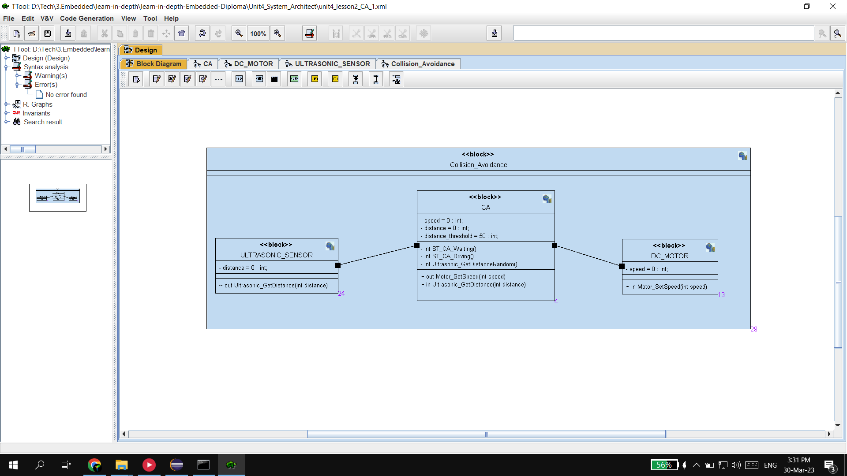

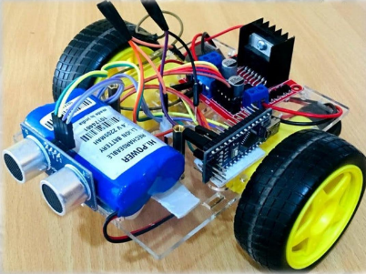

**Requirements**

The project is about car system which can be represented by a simple finite state machine of two states.

The system elements or blocks are DC motor, ultrasonic sensor and a microcontroller .

The ultrasonic sensor goes into a busy state in which it continuously reads the distance

When the ultrasonic sensor reads a distance more than the threshold distance which equal to 50 units, The machine or the car goes into driving state in which The DC motor starts with a specific speed which equals to 30 units and when the distance is lower than the threshold the car goes into waiting state.

**Collision Avoidance main Block**

**Ultrasonic sensor Block**

**DC Motor Block**

**Activity & Simulation**

